F

CAPSTONE Business Model

Drive–Aware Distraction Detection System – D.A.D.D.S.

Mark Rabinovich, Eric Cumiskey, Pavlo Grinchenko, Joerg Oxborough, Matthew Clark

April 4, 2019

# Executive Summary

As smart phones become more popular in our society, there is a growing number of crashes relating to their use while driving. Creating awareness for the extent of how driving alertness is affected while using a smartphone is vital to help reduce the amount of people that deem it okay to drive distracted. Beyond creating awareness, it is important to have a product that will warn the driver when they are driving in a distracted manner. This will aide in the effort to reduce the amount of crashes caused by distracted driving.

The Drive-Aware Distraction Detection System (D.A.D.D.S.), was developed to alert drivers when their driving behavior begins to indicate that they are distracted. The D.A.D.D. system can detect distraction of all types as it reads the resultant steering wheel inputs that the driver creates and compares it to the expected inputs from an intelligent front facing camera. The D.A.D.D. system will be installed in the vehicle manufacturers factories and will use the front facing camera that exists as standard in most new vehicles today.

The mission statement of the D.A.D.D.S. program is to make roads safer by reducing the number of crashes attributed to distracted driving. This is a solution to a modern problem that affects all drivers today.

Table of Contents

Executive Summary 2

Product Costing 4

Manufacturing 5

Distribution 7

Approach Major Automotive Companies 7

Licensing 8

Licensing Details 8

Installation 9

Safety Testing 9

Service 10

Market Planning 13

Exhibits 16

Exhibit 1. 16

Exhibit 2. 17

Exhibit 3. 18

Exhibit 4. 19

References 20

# Product Costing

In order to get a licensing price per unit, the total development cost was approximated to ensure a reasonable timeline for a return on the development investment. This was done by assuming a work force of four software engineers; two general software engineers to develop the software and two dedicated machine learning engineers to create the database and model. In addition to software engineers, an electrical engineer will be needed for half of the development process. This development team will be headed by a project manager who will oversee and communicate between teams. Finally, an accountant and an admin will be needed throughout the process to maintain the company’s finances and interact with the public respectively. The design process is expected to take a maximum of two years to create a fully developed program. The software engineers, project manager, and accountant will be full time for the entirety of the development process. The secretary and electrical engineer will join the team one year into development to not waste resources. With these expectations and work force numbers, the total development cost has been approximated to $1.3 million. Please refer to Exhibit 1 for more detailed information on the software development budget.

The D.A.D.D. system is targeted towards the major players in the Canadian automotive manufacturing industry. The top seven market share holders in the automotive manufacturing industry control 75% of the total market share. Within the first year we hope to gain a minimum of 2.5% of this market using our marketing plan as discussed later in this report. This will result in installation of the D.A.D.D. system in 1.875% of the total cars sold in Canada within our first year. This would result in a total of 29,000 units. With a licensing price of $50, the development cost can be completely covered within the first year of sales. Please refer to Exhibit 2 for more detailed information on the market analysis.

# Manufacturing

D.A.D.D.S. is a commercialized proprietary software which means the manufacturing process will consist of a software development process that divides software development work into two phases including design improvement, and product/project management. With this software development life cycle, our project team will complete specific deliverables on a pre-defined schedule to maintain and develop our product (Exhibit 4).

The software development methodology used for this product is extreme programming, focused on improving software quality and responsiveness in response to changing customer requirements. This methodology is a type of agile software development intended for frequent update releases in short development cycles. This rapid development cycle should increase productivity and create checkpoints at which new customer requests and new customers can be taken on.

Other methods used for our software development include paired programming with extensive code review focusing only on code elements in use. Expecting changes in the customer's requirements as time passes will be important for proactive development. However, efficient communications with the manufacturers will be key to our software development so a communications liaison will be hired to facilitate the communications of the design requirements of our customers. Frequent communication between the customers and programming engineers will create better understood problems and quicker solutions.

Our system is primarily consisting of a machine learning cycle, so our development process had to be catered toward this specific type of software. The D.A.D.D. system identifies distracted driving patterns based on previous experience and training data. This unique operation of our proprietary software means that we had to take on some unique product development steps. The process begins by getting correct data flowing from sensors to the on-board computers. This means that our software will have to be tailored for each specific Engine Control Unit (ECU) by our development engineers. Once the program works and is compatible with the ECU outputs, a large dataset of proper and distracted driving must be implemented into the system as a basis. With the initial database set, the model can be applied to get first iteration results. These results are analyzed for accuracy and the model is iterated with the best correct distracted driving estimations. This process is repeated until desired accuracy is achieved, and then, the model is ready to be licensed to car companies. Once a license deal basis has been established, our engineers will make any final specific adjustments to optimize for car model and sensor compatibility, allowing the final D.A.D.D. system to be released with the customer’s specifics. After securing the production and implementation of our system into new car models, system data can be collected from the car fleet and used to continue to improve the model and support iterations for new cars that are released. This information collection step is important to our development cycle, because as more data is collected and cleaned up, D.A.D.D.S. will use machine learning to improve accuracy and to develop a more efficient detection process.

Our product development speed and time to market will be highly dependent on the skills of our engineers and the requirements of the companies we sell our license too. The current prototype has already made a lot of headway toward the type of product we are putting to market, and since the groundwork has been set for this system, all that remains is to improve the process accuracy through supervised learning.

# Distribution

The purpose of distribution is to allow the product to be available at the right place and time. Distribution is a key element of success for every product on the market. The method of distribution must be critically analyzed and carefully selected in order to ensure that the product becomes widespread. The Drive-Aware Distraction Detection System is designed to minimize harm on the road, increase the driver’s and surrounding’s safety, and save lives. In order for this product to be the most effective in doing so, it must have a very large reach. If the product is sold individually to car owners, it will be very difficult and slow to incorporate and install the system in the majority of cars on the road. For ultimate efficiency and distribution, this product must be installed within a large portion of cars, and eventually, every car on the road. The best way to do this is by licensing the product to major car companies. Currently, most automobiles have built-in front facing cameras, the only hardware required for this system. D.A.D.D.S. can access the front camera and use the software to incorporate a chime or other indicator when someone is distracted. This is useful with regards to distribution as further manufacturing is not required. By targeting major automotive companies, the large automotive manufacturers would pre-install the system into every car they distribute, in turn, distributing the D.A.D.D.S. system to each car owner. An individual consumer would require access to the telemetry system in the car through the OBD port. Installation for an automotive manufacturer would be much easier and very simple for the manufactures and not required at all for users. It would also be better hidden.

### Approach Major Automotive Companies

We will be approaching major automotive companies with information on the product and reasons why it would be a great purchase. In installing these systems in new cars, manufacturers will only pay a small licensing fee as well as a conduct a small installation in order to incorporate the product. In doing so, the car will detect distracted drivers and inform them when it is unsafe. The car companies can now market their cars as safer, with a new technology that can detect distracted driving without a camera on the driver, never before seen.

### Licensing

Because we are going the route of licensing, it is only intellectual property that is being distributed. Therefore, we do not require manufacturing channels as this will all be covered by the vehicle manufacturer.

### Licensing Details

The D.A.D.D. system will incorporate a licensing distribution approach. After educating the market (as discussed in the market planning section of this report), the direction for the product will be to license it to major automotive manufacturers. This will allow them to incorporate D.A.D.D.S. into their vehicles.

We will provide a license per car and not per company. Each targeted company produces hundreds of thousands of cars. This will maximize profit for the Drive-Aware Distraction Detection System. A larger price per company will be a one time cost, and will not yield income after the initial purchase. Licensing for each car at a less expensive cost is feasible for the company and will provide the automotive company with many benefits. Each car will have an innovative technology that will deter drunk drivers and protect passengers and pedestrians from other means of distracted driving. The company would be able to market their cars as safer, and potentially increase the cost of the car by a small margin for the extra safety technology.

The first companies to pursue partnerships with would be companies with either a really high safety rating or a really low safety rating. The companies with a higher safety rating would benefit from our product helping maintain the high rating, and companies with a low rating would be incentivized to register a license with us to improve their low rating.

### Installation

All that is required of the manufacturing companies is to install the program. The only necessary hardware that the car must have is the front facing camera. For each car manufacturer, our engineers would need to tweak the software so it works with their telemetry. Each brand requires its own customization and potentially price. This will ensure that the safety is up to par.

### Safety Testing

In order to distribute widely, and successfully license to major car manufacturers, it is crucial that safety testing be conducted. Testing has been conducted to ensure that the system will chime when the driver is distracted, and not create false chimes, or not chime when a passenger is distracted. The purpose of this system is to minimize harm on the streets and increase safety for the passengers and surroundings.

# Service

Ongoing maintenance and service will be required to keep the D.A.D.D.S. in line with dealership’s expectations and up to date for new car models. With the physical and input feedback differences between car models, multiple versions of the model will have to be offered and updated to stay on track. However, the time scale of car model releases is typically on a yearly basis, and the initial license deal would have a D.A.D.D. system tapered to the specifics of the customer’s ECU. This means that a representative to deal with all licensing issues and concerns from dealerships will need to be hired. After the initial development of the D.A.D.D. system, the licensing development consultant will move on to the next project or licensing deal, while facilitating communication support services between the manufacturers and the engineers. The remaining team will consist of one software engineer and one machine learning engineer to update and maintain the program for the partner company. If multiple manufacturers require vastly different programming and update services, it could be easy for a small team to get overwhelmed. So, as more companies require our services, we expect to take on more maintenance teams.

The D.A.D.D. system will be licensed to manufacturers which will cut down the number of people required in customer service. Because our marketing plan focuses on obtaining licensing from a few of the largest car manufactures instead of multiple small players, the only customer service relationships we have will come from the car manufacturers. This marketing strategy will reduce the need for a call center or a large-scale website support. Instead, one employee will be dedicated to maintaining the relationships with manufacturers so more capital can be spent on maintaining and improving the software.

Since D.A.D.D.S. is a software, service will be in maintaining the functionality of the software. This can be further broken down into adaptive, perfective, corrective, and preventative duties. These post-delivery modifications are necessary to keep the D.A.D.D.S. technology up to date with recent advances.

Adaptive updates will come from changes in the software environment which result in root Database Management (DBMS) or Operating System (OS) changes. These service updates would be top priority since the functionality of our system completely depends on ECU input feedback. Any changes to the OS on the manufacturers side or the DBMS on the machine learning side would need immediate attention from the engineers to avoid halting operations. These changes are expected to be rare and unpredictable but noticeable as a part of a greater market shift to newer system management technologies. So, when these changes do come up, they will take top priority. Furthermore, since machine learning is still a constantly evolving field, it will be important to stay informed on any new developments in the field.

Perfective updates regard implementing updated user requirements to better the functionality of the system. The suggestions for these changes will come from the manufacturers and conveyed through by the communications liaison to the service engineers. Perfective changes take the next highest priority after adaptive changes since our revenue and reputation rely on strong relationships with big partners, so, any specific user requirements would have to be catered to as well. These updates are expected to be more common than adaptive updates and hold a high servicing priority. It is expected that the engineering team will be focused primarily on these types of updates or changes to initial systems sold.

Corrective and preventative changes are concerned with diagnosing or fixing problems, and maintenance for reliability, respectively. These updates would revolve around constantly improving code or training the machine learning system to improve overall functionality. So, changes would be worked on at a constant pace when no other updates are taking priority. Should a company raise any concerns of significant dysfunctionality, they would be noted as a perfective change and raised in priority. Overall, these changes are expected to be minor bug fixes and futureproofing the system through R&D partnerships with the manufacturers concerning the D.A.D.D. system. The machine learning aspect to this product also means that the model will constantly be changing and evolving so it will be the engineering team’s job to make sure the machine learning process is executed effectively.

Our servicing procedure is less broad due to working with only a few big companies, but, the specifications and requests or our customers must be taken more seriously by our development team.

# Market Planning

The first step for the roll out of the D.A.D.D. system will be to raise awareness of the perils of distracted driving. This system is designed to make drivers aware of when they are distracted while driving.

Currently, according to a report by the Children’s Hospital of Philadelphia Research Institute, 42% of teens surveyed in 2015 believed it was okay to text while driving. Another study conducted within the same report claims that brain activity that is focused on driving is reduced by 37% while attempting to text and drive simultaneously. Moreover, a study conducted by the Canadian Automobile Association (CAA) indicates that 26% of all crashes involve phone use.

The first few years of driving will dictate the habits that will be stuck with the driver for their lifetime. These habits can include texting while driving, checking emails while driving, as or even eating or putting on makeup in the rearview mirror. Therefore, it is important to first target high school students since that is the age range when most people first learn to drive and attain their driver’s licenses. The first step would be to provide workshops in high schools. In these workshops, students would be asked to drive in a simulator and then attempt to read or send a text message. They will quickly understand that it is very difficult to remain attentive on the road while trying to read or send a text message. This understanding of their own attentiveness going down while distracted and how much worse it is compared to what they believe will hopefully be enough to dissuade them from picking up their phones while driving.

While bringing awareness to the new drivers in high schools is important for their own self-awareness, teens are typically known to make decisions without regard for the consequences. Therefore, while having these workshops in high schools, there will also simultaneously be simulators set up in local malls and other public/semi-public spaces. These simulators will target parents and educate them on the severity of driving while distracted. Parents will have the opportunity to use the simulators themselves and attempt to drive while texting. The computer in the D.A.D.D. system will know that a driver is distracted without having a camera facing the driver. This should be telling for the driver and raise red flags that they are driving unsafely. This awareness in parents of the extremely reduced driving awareness while texting will incentivize them to purchase vehicles that have the D.A.D.D. system installed. This is especially the case if they are purchasing a car that their children will drive. Having the knowledge that their teen/young adult children are driving distracted will help their parenting in ensuring that their children are behaving safely. This will give parents peace of mind when their children take their car for a drive.

Once awareness of the D.A.D.D. system and how it can help reduce distracted driving is out, automotive manufacturers will likely be interested in incorporating a product like D.A.D.D.S. into their vehicles. They are then faced with two options. One of their options is to develop a similar product to D.A.D.D.S. internally and install it in their vehicles. Their other option is for the D.A.D.D. system to be licensed to them. Since D.A.D.D.S. is an already functioning product and can relatively easily be incorporated into a wide variety of vehicles, automotive manufacturers will likely not want to spend the amount of money necessary to develop a similar product internally when a solution like D.A.D.D.S. is available immediately for a small licensing fee. They are then able to market their cars with a new, innovative safety intelligence that has not yet been created. Parents of young drivers will be aware of this technology and will search for cars with a distracted driving system to increase safety for their children.

Essentially, the market planning for the D.A.D.D. system must be done in two parts. The first includes workshops and simulator displays in high schools and malls to raise awareness of the problem that is distracted driving while texting. And the second, assuming that enough awareness has been raised, involves approaching automotive manufacturers with licensing deals and explaining the cost benefits of licensing the D.A.D.D. system instead of attempting to develop a similar product internally.

The marketing expenses in total will account for 7% of our projected gross revenue. Details of the market analysis can be seen in exhibit 2. Furthermore, details on the monthly marketing plan budget can be reviewed in exhibit 3.

To supplement the main market planning methods mentioned above, additional advertising campaigns may be necessary to appeal and reach the market segment that does not frequent malls often or have children in high school. This can be done through mediums such as billboards on the side of roads, television advertisements, flyers to doors, Google AdWords, Instagram, Facebook networking, YouTube video promotion, and other means of social media. Social media is a key aspect of this strategy since it is increasing in popularity and used by most teenagers and young adults. Platforms such as Instagram and twitter are free for our company to market and spread the word about distracted driving and this system. Furthermore, Facebook is a very good platform that mothers use for networking and is therefore great for spreading the word on how D.A.D.D.S. can ensure that their kids are driving safely, not distracted. These advertisements will show the statistics mentioned above about the consequences and severity of diminished driving awareness while distracted. These methods will work together with the primary marketing methods to ensure that the roll out of D.A.D.D.S. is swift and effective.

# Exhibits

### Exhibit 1.

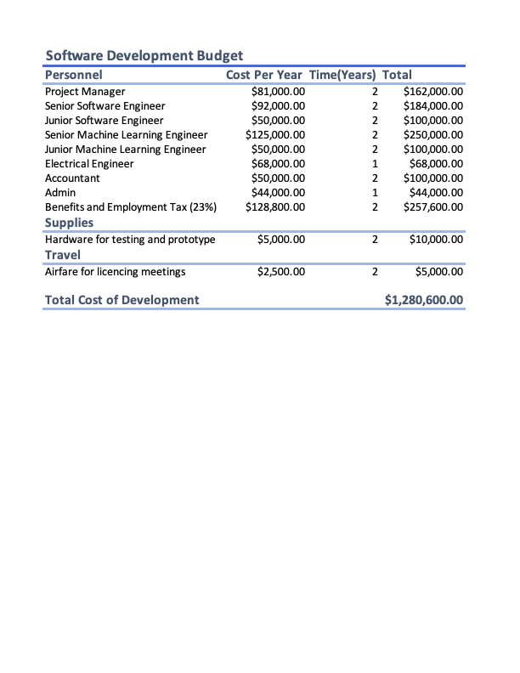

### Exhibit 2.

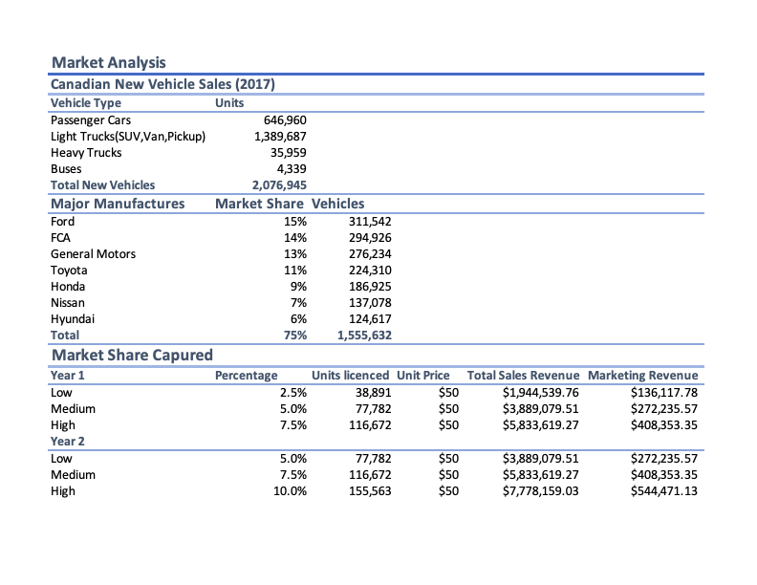

### Exhibit 3.



### Exhibit 4.

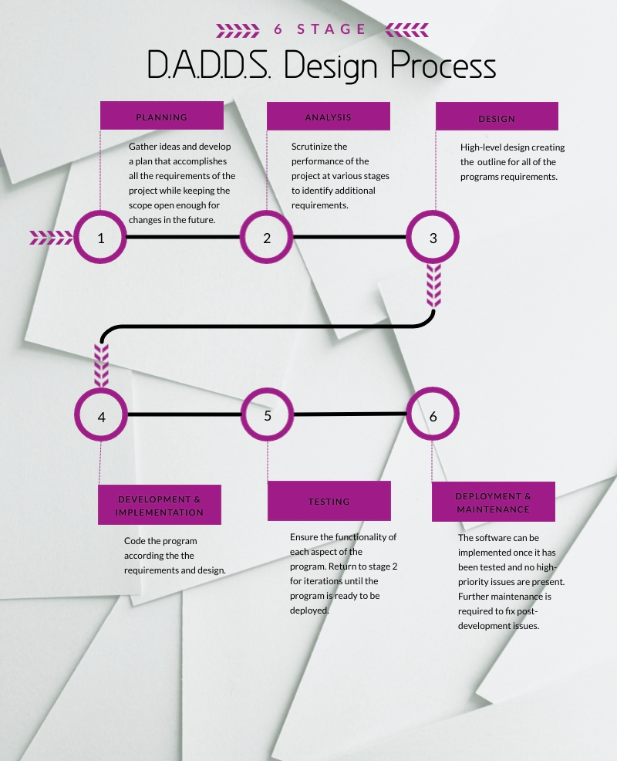

# References

“CAA National.” *CAA*, www.caa.ca/distracted-driving/statistics/.

“Cell Phones.” *Teen Driver Source*, www.teendriversource.org/teen-crash-risks-prevention/distracted-driving/cell-phones.

“March Market Snapshot.” *DesRosiers Automotive Consultants*, www.desrosiers.ca/sales.

*Statistics Canada: Canada's National Statistical Agency / Statistique Canada : Organisme Statistique National Du Canada*, www150.statcan.gc.ca/t1/tbl1/en/tv.action?pid=2010000201.